**Engineering Education; Research vs Engineering Design** (Speaker: Mr. Eugene Rutz, MS, PE, UCUC; June 19, 2015, 1:00 pm–2:30 pm)

Mr. Eugene Rutz has degrees in nuclear and mechanical engineering, and industry experience with companies such as Zimmer and GE before coming to UCUC 26 years ago. Mr. Rutz is an Academic Director in the College of Engineering & Applied Science at the UCUC who has oversight of the combined Bachelor's and Master's programs, the Master of Engineering programs and the collaborative program with regional high schools. Mr. Rutz also directs the Engineering Your Future - Ohio program, which is a partnership with UC and local high schools.

To begin, Mr. Rutz gave an overview of the two goals for the workshop:

1. To give the teacher participants more information about engineering education to share with their students.
2. To compare and contrast “research” vs “engineering design.”



**Figure 1:****Mr. Rutz Introducing Himself to the Teacher Participants**

The workshop was conducted in a conversational format. Mr. Rutz asked the participants to briefly introduce themselves, then began the first topic: “What is Engineering Education?” The group discussed ways to define STEM and engineering. Mr. Rutz passed out copies of some of the various engineering discipline undergraduate course schedules at UC. Participants were asked to find examples of courses specifically in the Engineering Department. Mr. Rutz commented that engineers use math, science and technology to solve real world problems. A level of competency and understanding in math will be very helpful. The group discussed the importance of Algebra fluency for engineers.

Mr. Rutz shared some answers to the question: Why would students choose engineering? Some students become engineers in part because they want to help others. Engineering is also a good career choice from a job security and financial standpoint. Engineering jobs have grown 7% from 2010 to 2014. Mechanical and electrical engineering are very broad fields with high interest and job opportunities. Civil engineers are projected to have 20% growth in the next 10 years. Some statistics indicate that China has been producing a lot more engineers than other countries in recent years, and Japan / S Korea have also been producing more engineers than the USA even though their populations are smaller. However, other researchers claim that the STEM crisis is a myth. What is known is that an engineer who graduates in the top half of their class is typically in high demand and makes a good salary. Mr. Rutz shared some details about the high school coursework needed to prepare for engineering at UC, the tuition/fees, the application deadline, and the co-op program.

A group discussion followed about the benefits and drawbacks of taking algebra early in middle school, and the pressures of perfectionistic expectations of college bound students. Mr. Rutz shared that one industry professional commented that he would rather hire a person who can solve an open-ended problem than a person who had a 4.0 from a prestigious school but did not have the same problem solving skills.

For the second part of the workshop, Mr. Rutz led a discussion on the scientific method vs engineering design. The features of each model were reviewed. Science is usually prescriptive, looking for a singular answer, and a scientist designs experiments. Engineering is more open ended. There is always more than one approach/ solution; an engineer designs projects seeking the best approach within the constraints. Mr. Rutz encouraged participants, when designing learning activities, to consider whether they are creating a science experience or an engineering experience.

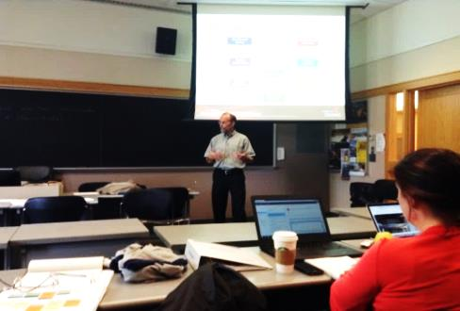

**Figure 2:****Mr. Rutz Explaining the Engineering Design Process**

Mr. Rutz shared the following two quotes to illustrate how the benefits vs drawbacks of engineering and science research may be expressed differently depending on the perspective of the speaker:

* “Science is about understanding nature, understanding what is. Engineering is about creating what has never been.” von Karman
* “In engineering you do not start a project unless you know the answer, while in science you do not start a project if you know the answer.” Jennings

To conclude the workshop, Mr. Rutz shared a few resources with teacher participants to assist them in designing engineering experiences. Participants were encouraged to visit the CEEMS website, teachengineering.org (curriculum for K-12 teachers; projects organized by subject, grade, cost, etc.), or the website for Engineering Your Future.

Through this workshop, the participants learned more about how to help their students consider and prepare for a future studying engineering. Participants also considered the distinct features of engineering design vs scientific research, for classroom activities and for helping students with career decisions. Finally, participants learned about resources and programs such as the Engineering Your Future - Ohio program.